Grouse Mountain's "Eye of the Wind": “A Beacon for Sustainability” NOT
http://www.scribd.com/doc/147478414/Our-Post-Truth-Culture-and-Greenwash (part 2 only)

From a few meters east of the electrically powered clock that pleases tourists, another tourist attraction is visible on a clear day – a tall white structure resembling a wind turbine. The “energizing” of that Grouse Mountain tourist attraction in September 2010 was marked by a BC Hydro press release. (BC Hydro, owned by the British Columbia government, is the principal generator and distributor of electricity in B.C.) Dave Cobb, BC Hydro’s CEO, declaimed: "With this successful energizing of The Eye of the Wind [the name of the tourist attraction], Grouse Mountain is not only starting down the road to energy self-sufficiency, but is also providing a tangible example of the kind of strong working relationships BC Hydro enjoys building with partners committed to clean and renewable energy." Stuart McLaughlin, President of Grouse Mountain Resorts, boldly declared: “British Columbia has a shining new beacon for sustainability.” And Bill Bennett, provincial Minister of Energy, opined: “Vancouver's first commercially viable wind turbine … [an] icon … it will inspire [further] renewable energy projects." The BC Hydro press release quoted without reservation and thus endorsed Grouse Mountain Resorts' false claim that the electricity produced by the Eye of the Wind will be "enough to power up to 400 homes a year.” (Note 2a)

The Eye's view room reached -- after buying a ticket -- by an elevator, has a terrific view from its windows and, more importantly for the purposes of this article, houses two computer screens showing statistics of the facility’s electrical production since inception.

Per the screens, 11 November 2012, lifetime production was 284,055 kwh indicating an annual production of ~133,000 kwh or enough for about 12 average British Columbian homes, not 400. (A kilowatt hour is 1000 watts for an hour and is commonly written as kwh. An average B.C. home consumes annually about 11,000 kwh.) (Note 2b)

The Eye of the Wind is located on a comparatively windless mountain as may be checked online in the Canadian Wind Atlas and as must have been known in 2010 by most regular users of Grouse ski runs, the president of Grouse Mountain Resorts, and key BC Hydro employees.

Web weather reports of actual wind speeds on Grouse and projected wind speeds for seven day periods rarely show wind speeds of over 10 kilometers per hour. The blades of the Eye require a wind speed of above 9.7 kilometers per hour before they will turn. (Note 2c)

A wind-turbine of 1.5 megawatt capacity, the Eye’s capacity, without an elevator and a view room, costs in energy terms about 4.2 million kilowatt hours (kwh) to manufac-ture and install when part of a wind farm. The Eye of the Wind will produce less than 3.5 million kwh in a 25 year period and will not repay its embodied energy over its lifetime, assuming a 25 year life. The Eye is not ‘sustainable’ in any ecological sense of the word; it is an energy sink. (Note 2d)
Sustainability has a range of possible meanings in our post-truth world and perhaps the President of Grouse Mountain Resorts was thinking of ‘sustainability’ in its narrow economic meaning of ‘profit center’ when he claimed that the Eye is "a shining new beacon for sustainability.” A ticket checker stationed by the elevator at the base of the Eye informed me that the viewing room had 11,000 visitors in August 2012. Conservatively assume 40,000 visitors a year paying $15 each for admission to the Eye's viewing room, then the tourist attraction (that I estimate cost a bit over two million dollars) brings in at least $600,000 annually in tourist revenue. (Note 2e)

The electricity produced by the Eye in 2012 had, at BC Hydro’s highest residential selling rate, a monetary value of about $13,500 or about 2% of my estimate of the Eye's 2012 tourism revenue.

The Eye looks like a wind turbine but in economic terms it is a tourist attraction whose attractiveness is dependent in part on greenwash advertising sanctioned and amplified by the provincial government and BC Hydro. Remember the previously quoted B.C. Minister of Energy's endorsement: “Vancouver's first commercially viable wind turbine" and the CEO of provincially owned BC Hydro declaiming: "With this successful energizing of The Eye of the Wind, Grouse Mountain is ... starting down the road to energy self-sufficiency.” And also think of the plaque on Vancouver’s fake “steam powered” clock.

Again, some BC Hydro employees must have known in 2010 that the top of Grouse Mountain, compared to other potential B.C. wind power sites, is windless. And those BC Hydro employees also must have known that a wind turbine of 1.5 megawatt capacity on Grouse would not produce “enough [electricity] to power up to 400 homes a year.”
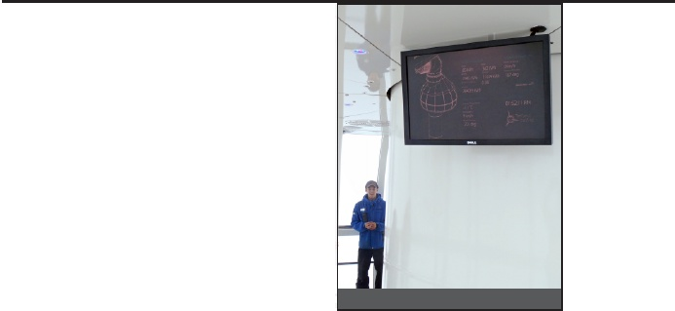

And it’s not just ‘tourists’ who are lied to: the 2008 vote by the North Vancouver District Council to approve the development permit for “a wind turbine” on Grouse was 4 to 3, after “a passion-ate debate.” The District’s staff report on the “wind turbine,” presented to council before the vote and recommending approval of a development permit, reads in part: "The turbine ... is anticipated to generate ... the power used by 400 homes. This equates to an annual reduction of 1600 tonnes of carbon." (Note 2f)

If staff had accurately reported to the District Council that wind power generation on Grouse would be minimal, that the proposed project would be an energy sink and was economically viable only as a tourist attraction, possibly the District Council would have voted against issuing the development permit.

Why has the Eye of the Wind’s failure to produce 5% of its advertised electrical output received no attention from main stream commentators? Why has no employee of a climate change non-profit blown a whistle? (The David Suzuki Foundation has 57 full time employees per a 2011 Revenue Canada filing.) How come no professional journalist or climate change academic has mentioned publicly the Eye of the Wind’s non-viability as an energy producer? The computer screens showing kilowatt hours of electricity produced must have been viewed by hundreds of people who understand the numbers displayed and make part of their living writing or talking about ‘green technology,’ ‘sustainability,’ and ‘climate change.’ The post-truth statement “… enough electricity … 400 homes” is etched into the glass opposite one of the Eye’s computer screens. The usually non-turning blades of the iconic virtual wind turbine are visible from downtown Vancouver. (Note 2g)

!"#$%& ()"* +,-.. */ - ,-0+% 1()&*1 () !2%3. 4(%1 0**5

(2a) The BC Hydro press release: http://www.bchydro.com/news/press_centre/news_releases/2010.html -- on page 2 of that site : September 22, BC Hydro Congratulates... For Grouse Mountain Resorts own press release: http://www.grousemountain.com/press_releases/bc-hydro-congratulates-grouse-mountain Also see: http://www.grousemountain.com/press_releases/the-eye-of-the-wind-welcomes-the-world

At 100% of capacity the Eye would produce about enough electricity for 1200 average BC homes - for more on “capacity” see note 2b.

(2b) The screens showed life time production of 284,055 kwh on 11 November 2012. The Eye was “energized” about 22 September 2010, 2.14 years earlier. Divide 284,055 kwh by 2.14 and the result is annual electrical production – roughly 133,000 hours. (On 20 May 2013, six months and nine days after the screens showed life time production of 284,055 kwh, the figure for life time production was 333,492 kwh.)

An average B.C. home/ household consumes annually 11,000 kwh: Google: BC 11,000 kwh quick facts.

(An average UK household consumes 4800 kwh annually http://www.carbonindependent.org/sources_home_energy.htm )

(2c) Canadian Wind Atlas: http://www.windatlas.ca/en/index.php

For wind speed reports: http://www.theweathernetwork.com/

The blades of the turbine require a wind speed of above 9.7 kilometers per hour to turn:
http://www.grousemountain.com/posts/the-eye-of-the-wind-revolution

Often actual output of new wind turbines is lower than anticipated output. The Eye's electric output, I have been told, is significantly less than anticipated due primarily to the unforeseen icing of the blades in winter. But, even supposing projections of electrical output before the Eye’s “energizing” were a wildly optimistic three times current annual output, that projected output would not have been sufficient for 40 average B.C. homes let alone 400.

In the windiest B.C. locations, say Cape Scott on Vancouver Island, a wind turbine with the Eye’s capacity (1.5 megawatts) might operate on average at one third of capacity and produce annually enough electricity for 400 B.C. homes. (Wind speeds are seldom optimal even in windy locations and turbines do need maintenance.) At 100% of capacity an imaginary 1.5 megawatt wind turbine would produce about enough electricity annually to service 1200 average B.C. homes.

(A megawatt is 1000 killowatts -- a 1.5 megawatt capacity wind turbine running at full capacity for an hour will produce 1500 kilowatt hours of electricity. Running at 100% of capacity for a year a 1.5 megawatt turbine would produce about thirteen million kwh (1500 x 24 x 365). Some readers may find the Wikipedia article on electrical measurements useful: http://en.wikipedia.org/wiki/Kilowatt_hour )

The language of the Grouse Mountain Resorts quote in the first paragraph of the main text is slippery: "up to [my italics] 400 homes." In the Eye's view room slightly different language is used: "... can generate enough electricity in a year to service the needs of 400 homes." (See photo p 6 of text and note that the words “can generate” have a different meaning than the words “does generate.”) Organizations (and individuals) communicating in good faith do not use slippery language to fudge facts.

(The disinformation about the Eye’s ‘green’ credentials disseminated by Grouse Mountain Resorts is not typical of the Grouse Mountain approach. Staff at the resort are well trained, the second floor bistro is good value, the organized free activities are worthwhile -- after my first visit to the Eye I bought an annual pass.
#26 9<+ 9,/($9
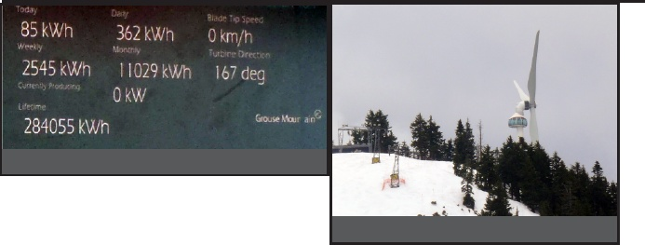

(2d) For a turbine’s energy cost see “Net Energy Analysis” section:
http://www.eoearth.org/article/Energy_return_on_investment_%28EROI%29,_economic_feasibility_and_carbon_intensity_of_a_hypothetical_Lake_Ontario_wind_farm

(2e) Fifteen dollars per visit is a low estimate of actual revenue generated by the Eye. For some a visit to the Eye is the tipping point motivation for an ascent up Grouse and those visitors will, unless they trek up, need to pay not just for the entrance to the Eye’s observation room but also for gondola tickets and perhaps for parking. And possibly those “tipping point” visitors will also choose to buy a souvenir, food, a ticket to another attraction, or an annual pass. For ticket prices: http://www.grousemountain.com/eye-of-the-wind

(2f) For the staﬀ report and the “400 homes” quote: http://www.dnv.org/upload/documents/Council_Agendas_Minutes/cm081006.htm and on that web page go to “Council Matters #2” and then click the link to the September 23, 2008 report and see p 3.

For the “passionate debate”: http://www.canada.com/theprovince/news/story.html?id=ee92c5cc-e56b-4d05-b1a6-f438419fcf8d&k=68621

(2g) Art Wilson -- now dead apparently (I did try to track him down) -- in web comments under a Georgia Straight piece celebrating the Eye's "energizing" presented the basic numerical analysis that I flesh out. A sample of Mr. Wilson’s comments: “The production and installation of this wind turbine carries a considerable carbon cost which would have better been spent by locating it at a more productive site … if Grouse Mountain really wanted to be Green then they could just turn oﬀ their lights when there is no night skiing. No cost, carbon or dollars, but that would be like turning oﬀ the lights on a billboard ... Can we please get some investigative journalism instead of Press Release regurgitation?” (To access Mr. Wilson’s full comments, google: "journalism instead of Press Release regurgitation" Straight and then scroll down the Straight’s
web page.)

In September 2012, inside the view room of the Eye, after a short conversation and sensing a similar world view, I exchanged cards with another visitor. Only after leaving the structure did I read the card and realize I had been talking to the author of Green Illusions,
Ozzie Zehner. A chapter on wind power in the book is titled “... Flurry of Limitations.” Zehner's central thesis that resonates with my own view: “We don’t have an energy crisis. We have a consumption and leaky bucket crisis. The supposed clean energy sources have real problems.”
See/ hear Zehner at
http://www.youtube.com/watch?v=JJ9-jYfpwfw

