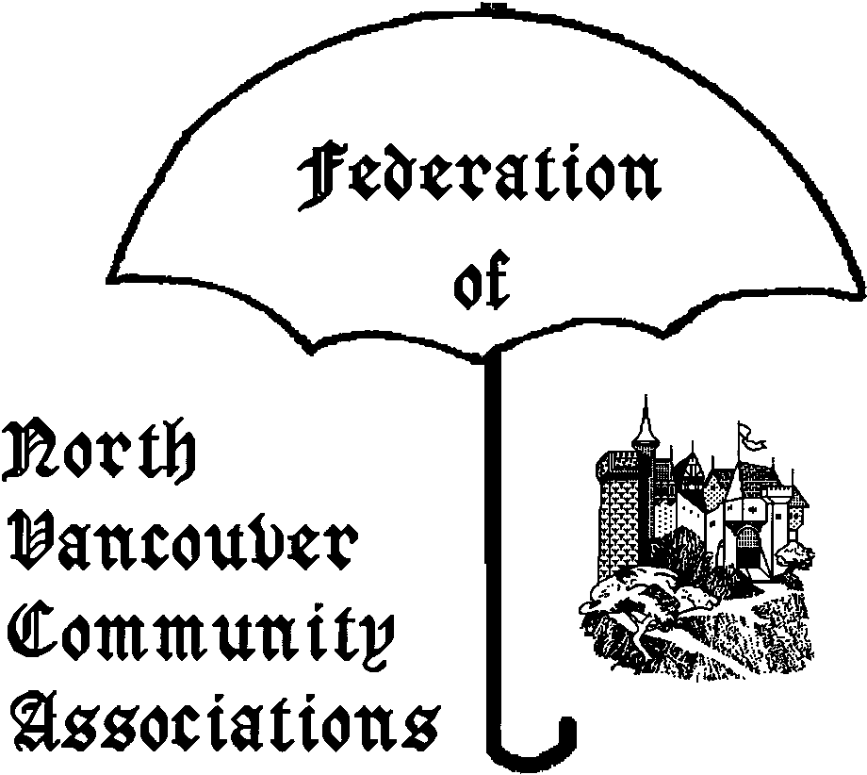
FONVCA AGENDA
THURSDAY Jan 18th 2007

Place: DNV Hall 355 W. Queens Rd V7N 2K6
Time: 7:00-9:00pm
Chair: Diana Belhouse – Delbrook CA.
Telephone/email:604-987-1656

1. Order/content of Agenda

2. Adoption of Minutes of Nov 16th

3. Old Business

3.1 Review of FONVCA mandate/process
Continue debate of Nov 16/2006

4. Correspondence Issues

4.1 Business arising from 14 regular emails:

4.2 Non-Posted letters – 2 this period

4.3 New host for FONVCA web site – Corrie Kost

4.4 2007-2011 Financial Plan Presentation
http://www.fonvca.org/letters/2006/13nov-to/David_Sewell_8jan2007.pdf

5. New Business

5.1 Status of North Shore TAC
(Transportation Advisory Committee) – Cathy Adams
http://www.westvancouver.ca/article.asp?a=3890&c=690

Council and other District issues.

5.2 Plan to walk
http://www.lgc.org/freepub/PDF/Land_Use/focus/plan_to_walk.pdf

5.3 Windstorms & DNV Parks Tree Damage
- Lyle Craver

5.4 Seylynn Open House (10 Jan 2007)
http://www.seylynn.info/

5.5 Marine Drive Improvement Strategy
http://www.dnv.org/upload/documents/Public_Meeting/pm070115.htm

5.6 “Aggressive Dogs” –see
http://dnv.org/upload/documents/Council_Reports/00487.pdf
“Dangerous Dogs” –see
http://www.workingdogs.com/doc0084.htm

5.7 COSTCO in DNV
http://www.northshoreoutlook.com/portals-code/list.cgi?paper=43&cat=23&id=805495&more=
http://www.dnv.org/article.asp?a=3597
http://www.costconorthvancouver.com/index.html

5.8 Chlorine Plant Expansion
http://www.northshoreoutlook.com/portals-code/list.cgi?paper=43&cat=23&id=805497&more=

http://www.nsnews.com/issues06/w112606/121106/news/121106nn8.html

http://www.fonvca.org/agendas/jan2007/Canexus-questions.pdf & /canexus-answers.pdf

6. Any Other Business
6.1 Legal Issues
Sidewalk Maintenance Requirements: More than 1” can make a difference –
http://www.courts.gov.bc.ca/jdb-txt/sc/06/01/2006bcsc0136.htm

Denying a Business Licence/Renewal is tricky:
http://www.courts.gov.bc.ca/jdb-txt/sc/06/10/2006bcsc1072.htm and
http://schenklaw.ca/?cat=5

Right to criticize local government – see
http://www.canlii.org/on/cas/onsc/2006/2006onsc10892.html

Making Municipal Governments More Accountable
- need for effective Open Meetings Laws
http://www.ipc.on.ca/images/Resources/open-mtg.pdf

Municipal Matters - http://schenklaw.ca/
- Infrastructure fees can’t be used as a cash cow
- Billboard issue in Vancouver
7. Chair & Date of next meeting.
February 15th 2007

Attachments
List of Email to FONVCA - ONLY NEW ENTRIES
OUTSTANDING COUNCIL ITEMS
-Cat Regulation Bylaw -Review of Zoning Bylaw
-Securing of vehicle load bylaw -District-wide OCP
-Snow removal for single family homes bylaw

Correspondence/Subject Ordered by Date
13 November 2006 → 14 January 2007

LINK | SUBJECT
http://www.fonvca.org/letters/2006/13nov-to/Wendy_Qureshi_13nov2006.pdf | Seymour Development
http://www.fonvca.org/letters/2006/13nov-to/Wendy_Qureshi_13nov2006b.pdf | Sustainable Development
http://www.fonvca.org/letters/2006/13nov-to/Patrick_Murray_20nov2006.pdf | Conduct at November 20th Council Meeting
http://www.fonvca.org/letters/2006/13nov-to/Knud_Hille_2dec2006.pdf | Council Committees
http://www.fonvca.org/letters/2006/13nov-to/Elizabeth_James_6dec2006.pdf | TRANSLINK – Light Rail
http://www.fonvca.org/letters/2006/13nov-to/Elizabeth_James_6dec2006b.pdf | TRANSLINK – Light Rail
http://www.fonvca.org/letters/2006/13nov-to/Elizabeth_James_14dec2006.pdf | GVRD Model - Regional Governance
http://www.fonvca.org/letters/2006/13nov-to/Wendy_Qureshi_27dec2006.pdf | Lynn Valley Town Centre – Property Management Service
http://www.fonvca.org/letters/2006/13nov-to/Ernie_Crist_1jan2006.pdf | Lynn Valley – Whiteley Court
http://www.fonvca.org/letters/2006/13nov-to/Ernie_Crist_1jan2006b.pdf | Civic Democracy
http://www.fonvca.org/letters/2006/13nov-to/Elizabeth_James_4jan2007.pdf | Recycling - Tires
http://www.fonvca.org/letters/2006/13nov-to/David_Sewell_8jan2007.pdf | Financial Plan 2007-2011
http://www.fonvca.org/letters/2006/13nov-to/Wendy_Qureshi_8jan2007.pdf | Chlorine Plant
http://www.fonvca.org/letters/2006/13nov-to/OAG.pdf | 2006 Report form the Office of the Auditor General of Canada

For details/history see
http://www.fonvca.org/letters/index-letters-total-jan2007.html

