**After aboriginal land title ruling, why not protect property rights of all Canadians?**

[Andrew Coyne](http://fullcomment.nationalpost.com/author/acoynenp/) | June 27, 2014 9:08 PM ET

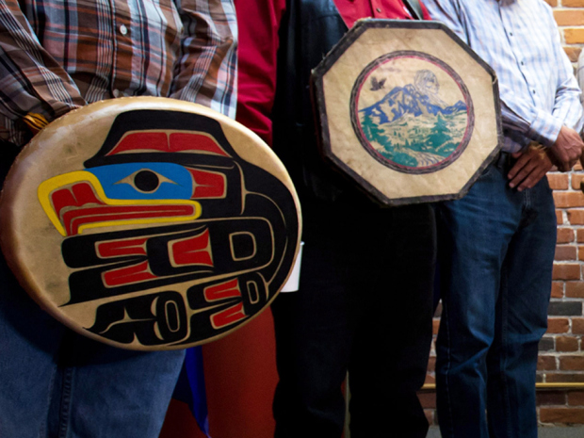

Darryl Dyck/The Canadian PressThe same Constitution that entrenched aboriginal rights, from which we now see derived aboriginal title, declined to protect the right to own property.

The Supreme Court’s Tsilhqot’in decision, as everyone instantly recognized, is a legal earthquake. Though in some ways a summation of the court’s previous rulings, it is the first to confer aboriginal title to a specific piece of land, and the first to define it in concrete terms.

In so doing, it radically extends previous lower court conceptions of title, to include not only the actual settlements historically occupied by aboriginal groups, but all lands over which they can show they “exercised effective control” in a continuous and exclusive fashion, as for example traditional hunting and fishing grounds. Where aboriginal title has been established, governments will normally be obliged to obtain the consent of the title-holders to proceed with development; or where consent is not granted, may proceed only subject to the usual conditions by which rights may be overridden: they must have a pressing and substantial purpose, the infringement of title must be the minimum necessary to achieve it, and so on. The mere assertion of title is enough to impose a duty of consultation pending resolution of the claim, in proportion to its legitimacy.

As such, it is clear, the decision is also an economic earthquake. At a minimum, it will greatly complicate future resource development projects, at considerable cost both to their proponents and the wider community. This is not only true in British Columbia, whose territory, in the absence of the kinds of formal treaties that were signed in the rest of the country, is subject to overlapping aboriginal claims adding up to more than 100% of the total, but in the rest of Canada as well.

**Related**

* [Supreme Court B.C. land-claim ruling has staggering implications for Canadian resource projects](http://news.nationalpost.com/2014/06/26/supreme-court-b-c-land-claim-ruling-has-staggering-implications-for-canadian-energy-projects/)
* [Supreme Court grants land title to B.C. First Nation in historic ruling that could impact Northern Gateway](http://news.nationalpost.com/2014/06/26/supreme-court-grants-land-title-to-b-c-first-nation-in-historic-ruling-that-could-impact-northern-gateway/)
* [Peter Foster: Aboriginal response to Supreme Court land ruling should be to move forward](http://business.financialpost.com/2014/06/26/peter-foster-aboriginal-response-to-supreme-court-land-ruling-should-be-to-move-forward/)

And yet the decision was, by and large, greeted with equanimity. This is quite remarkable, on its face. The decision was hardly a foregone conclusion: precedent setting in itself, it overturned a B.C. Court of Appeal ruling, rejecting with it the arguments of both the federal and provincial governments. At a stroke, it has handed native groups enormous bargaining power, not only with regard to specific development proposals, but in the broader negotiations over treaty rights. As a Vancouver lawyer put it, “the result will be that reasonably large tracts of [Crown] land in the province will be privatized.”

I do not say this to be in any way critical. The unanimity of the court lends the decision particular weight in legal terms. And the practical effects may well be as benign to the wider community as they are beneficial to aboriginal communities themselves. Environmentalists should rejoice that what were formerly Crown lands, subject to the usual short-term political and business temptation to over-development, will now be put under more direct ownership, by groups with both a vested interest in preserving them from despoliation and the legal authority to enforce it. Business groups, meanwhile, are already touting the benefits of greater “certainty”: with clear title and recourse to the courts, aboriginal groups may feel less need to resort to blockades and other forms of obstruction.

And yet the broadly favourable reaction to the decision has a simpler explanation, though it is no less remarkable for that. It is, I think, rooted in a basic respect for rights. The majority has interests, we understand, but the minority has rights, and while those rights are not absolute — contrary to some of the more excited reactions, provincial and federal law will continue to apply on aboriginal lands — they cannot simply be trampled over.

They have those rights, what is more, because the majority agreed they should. As esoteric as some of the arguments in this case may seem, the concepts are familiar in other respects. Aboriginal title, as enumerated by the court, is informed in part by common law notions of possession, adapted to aboriginal traditions; though not alike to fee simple ownership, it resembles it in important ways.

But whatever its philosophical foundations, it is a legal reality today, not by virtue of common law or “inherent” right, but because of the written constitutional law of this country: from the Constitution Act 1982 all the way back to the Royal Proclamation of 1763. It is the authority of the Constitution of Canada that the Court invokes to defend aboriginal title, and no other. Common law can be overridden by statute. Inherent rights still need courts to enforce them. It is constitutional entrenchment that gives shape to rights, and it is democratically elected governments that write constitutions. The “inconvenience” of aboriginal title for governments and developers is one we have taken upon ourselves.

All of which raises an interesting question. If we are agreed to constitutionally protect the property rights of some Canadians, why do we shrink from doing the same for others? Recall that the same Constitution that entrenched aboriginal rights, from which we now see derived aboriginal title, declined to protect the right to own property — a right that is also founded in common law, and that is often spelled out in statute, but was deemed unworthy of constitutional entrenchment. Like aboriginal title, the right to property is not absolute: in the constitutions of other countries, it is typically expressed as the right not to be deprived of one’s property except by due process of law, and with just compensation. And yet at the time it was considered expendable. It would be too costly to have to compensate property holders for infringing on their rights. It would be inconvenient.

Suppose, then, a government wishes to put a power line through a particular stretch of land. If the land is subject to aboriginal title, all of the rights the Court has now delineated kick in. But if it is merely someone’s property, no such constitutionally guaranteed rights apply. Now that we have defined and accepted aboriginal title as a constitutional right, is it not time this discrepancy was redressed?