30 Jun 2016 The Vancouver Sun ROB SHAW rshaw@postmedia.com twitter.com/robshaw_vansun

**Liberals and NDP present differing solutions to housing crisis**

**Skyrocketing real estate may shape upcoming provincial election**

VICTORIA The governing B.C. Liberals and the Opposition NDP squared off Wednesday with starkly different solutions to Metro Vancouver’s housing affordability crisis, providing a preview of what is likely to be one of the hottest issues in next year’s provincial election.

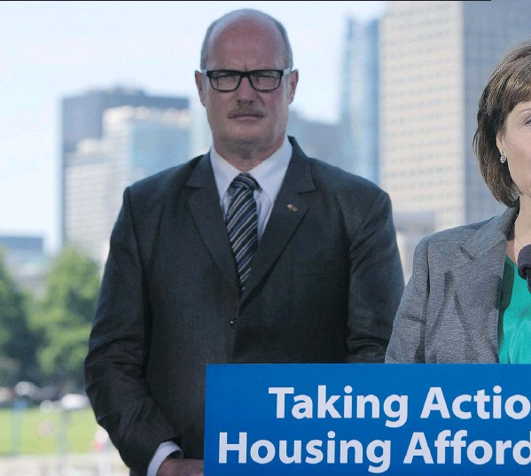

*JONATHAN HAYWARD/THE CANADIAN PRESS* B.C. Finance Minister Michael de Jong looks on as Premier Christy Clark announces the government will end selfregulation in the B.C. real estate industry.

The duelling announcements reinforced their divergent positions: The NDP’s push to reduce demand by penalizing foreign investors and vacant homes; the Liberal argument that adding thousands of units to the housing supply is the best way to cool the market.

The only point of agreement between the two parties was that there was no avoiding the issue in one of the key battlegrounds for the next election.

Up for grabs are mainly young, middle-class voters who can’t afford to buy a home in the Lower Mainland — where 48 of B.C.’s 87 provincial ridings are located — and who could make skyrocketing real estate a ballot box issue in May, 2017.

“I think housing prices were shaping up to be one of the top issues for the coming election,” said veteran political scientist Norman Ruff. “You don’t need to look at public opinion polls, you just need to listen to people in conversation. That and school closures are the two issues that the public are talking about.

“This was growing to such proportions they’ve been forced to intervene. It runs counter to the direction that the Liberal government has taken for the last 15 years, but the circumstances were moving to crisis proportions — if they are not already at crisis proportions.”

The NDP began Wednesday announcing an “independent task force” of police, prosecutors, lawyers and tax experts to crack down on the money-laundering, fraud and tax evasion that the party says is contributing to skyrocketing housing prices.

Premier Christy Clark responded fewer than two hours later by revoking the real estate industry’s self-policing powers, saying it had lost the privilege of self-regulation after a series of scandals.

“In the coming days and weeks there’s more to come,” Clark said, foreshadowing a series of planned press conferences on her government’s housing response.

“Clearly it’s a political hot spot and people are outraged about what’s going on,” said Tsur Somerville, a business professor at the University of B.C.

“No one likes to see 24-year-old realtors driving Lamborghinis. There’s a feeling people have, even if it’s not true, that realtors aren’t working for us, they are the ones getting this sort of windfall from the increase of prices.”

The premier’s crackdown on real estate agents also signalled how seriously her government views the political risk on housing, because ending self-regulation far exceeded any recommendation made Tuesday by an independent panel that researched realtor conduct.

Outspoken retiring Liberal MLA Moira Stilwell tweeted Wednesday: “Had to happen — people are enraged — misplaced or not.”

Clark’s rush to address housing affordability comes after months of being hounded by the NDP but before the return of much of the data she had promised to collect on the cause of the price hikes before imposing solutions.

The Clark government has said it’s been slow to intervene because it feared inadvertently lowering housing prices, leaving homeowners owing more on their mortgages than their home was worth. A drop in housing prices by 25 per cent would leave almost one in four mortgages — more than one million people — in negative territory nationwide, the Bank of Canada has said.

The political parties have danced cautiously around that issue, not wanting to be the ones blamed for reforms that might burst what several banks have declared is a housing bubble in Metro Vancouver and Toronto.

The Opposition has proposed a plan by academics that would tax speculators who own property but don’t declare any B.C. income. Vancouver Mayor Gregor Robertson repeated demands Wednesday for a tax on vacant homes.

“All of the suggestions we’ve had are on the table and we’ve been thinking about them,” said Clark. “We’ve done substantial work ... investigating what other countries do, and what other parts of this country have done, and what’s worked.”

Australia implemented a ban on foreign purchases of existing housing five years ago. Foreign buyers are mainly restricted to building new housing. But some academics have said it hasn’t curtailed prices and shouldn’t be grafted on to B.C.

The B.C. Liberals may be boosted by looming action from Ottawa, which is consulting with the Ontario and B.C. governments on ideas to cool the housing market. A non-owner speculation tax administered by the federal government — which has much of the data on mortgages, income taxes and citizenship — could generate money used for an affordable housing plan that the federal housing minister said this week is in development.

Prime Minister Justin Trudeau has also said he’s sympathetic to using federal powers to force increased density along transit lines — which Clark has said is key to her housing plan.

“One level of government isn’t going to be able to solve this on its own,” Clark said Wednesday. “It’s going to take all three levels of government pulling together.”