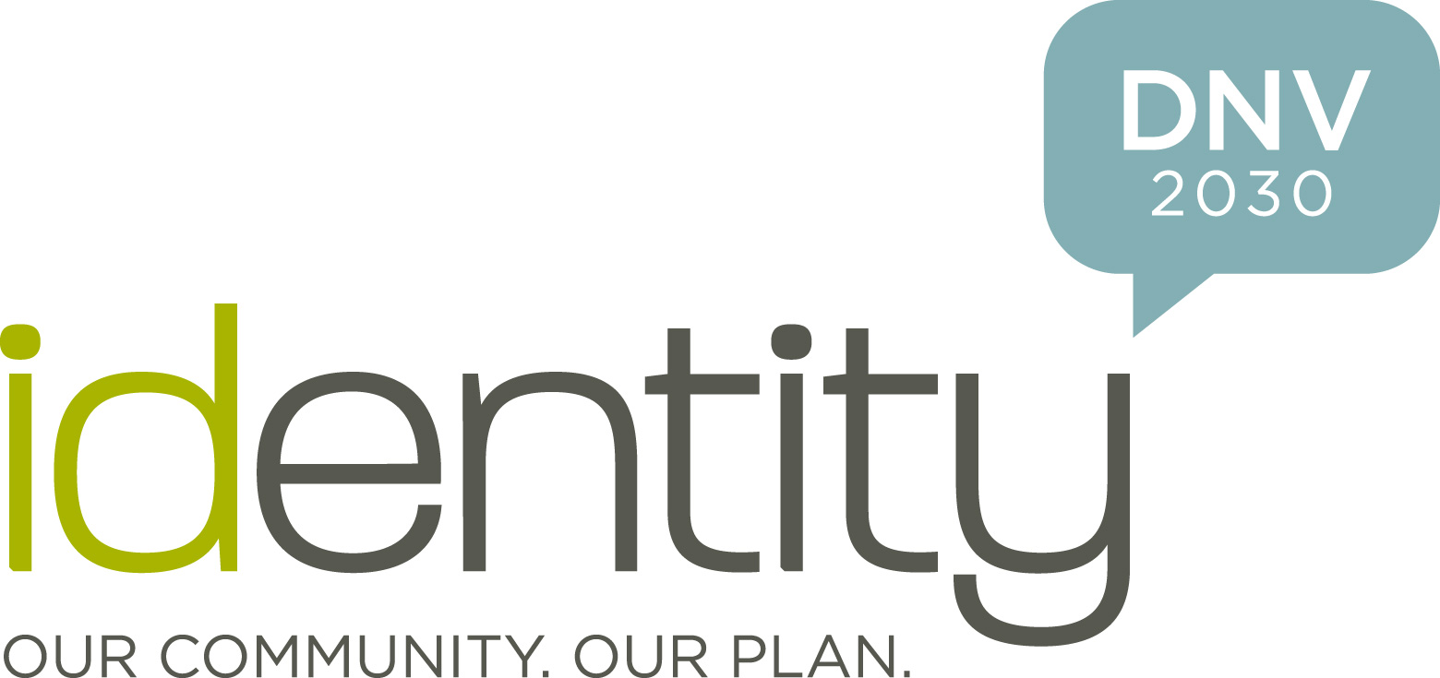
newsrelease

For Immediate Release May 26, 2009

District of North Vancouver launches
Official Community Plan review process

North Vancouver, B.C. To set direction towards a bright and sustainable future, the District of North Vancouver has just launched a comprehensive review of its Official Community Plan (OCP).

‘Identity DNV 2030’ is an 18-month long planning and engagement effort that seeks extensive community input to shape the new OCP.

An Official Community Plan (OCP) is an important document that sets direction for growth, transportation, housing, services and infrastructure while considering health, diversity, the natural environment, climate change, and the local economy. This review will be an open and inclusive process, engaging the community throughout the process in order to develop a long term vision for the District’s future, and a means to achieve it.

Three community events will be held in June as a way to raise awareness of the OCP review, and to ensure the broadest possible participation of District citizens and stakeholders in the process.

“District Council encourages all residents to participate in the OCP review by attending the upcoming Community Forums,” said North Vancouver District Mayor Richard Walton. “These discussions will provide critical input to Council about the kind of community you want your children and grandchildren to have. The dreams, concerns, ideas and advice members of our community provide will help shape a robust vision for the new OCP which will help positively shape our future quality of life.”

The Community forums will take place, as follows:

“Our Future” – Tuesday, June 9, 6:00-9:00 PM, District Hall (355 W. Queens Rd)
A fun and engaging panel and Theatre Sports will get you thinking and talking about the future of your community. Be part of the dialogue, right from the start.

“Our People” – Saturday, June 20, 1:00-4:00 PM, Norgate Elementary School (1295 Sowden St)
Who exactly are we planning for? Are the community demographics changing? What are our community’s greatest strengths and needs? How can we bring people together?

“Our Places” – Thursday, June 25, 6:00-9:00 PM, North Shore Winter Club (1325 E. Keith Rd)
How can we balance human activities and the environment? Can we connect neighbourhoods, increase mobility, and enhance the economy? Can recreation and ecology thrive together?

District staff will be at community events throughout the summer to raise awareness about the OCP process. Additional workshops and a Visioning Summit will be held in the fall.

For more information on the OCP process, or to preregister for an event, visit the District’s Official Community Plan website at identity.dnv.org; call 604-990-2421 or e-mail identity@dnv.org.

- 30 –

For more information contact
District of North Vancouver - Communications Office - at 604-990-2459.

District of North Vancouver / 355 W. Queens Rd, North Vancouver, BC V7N 4N5 / Tel: 604-990-2311 / Web: www.dnv.org

