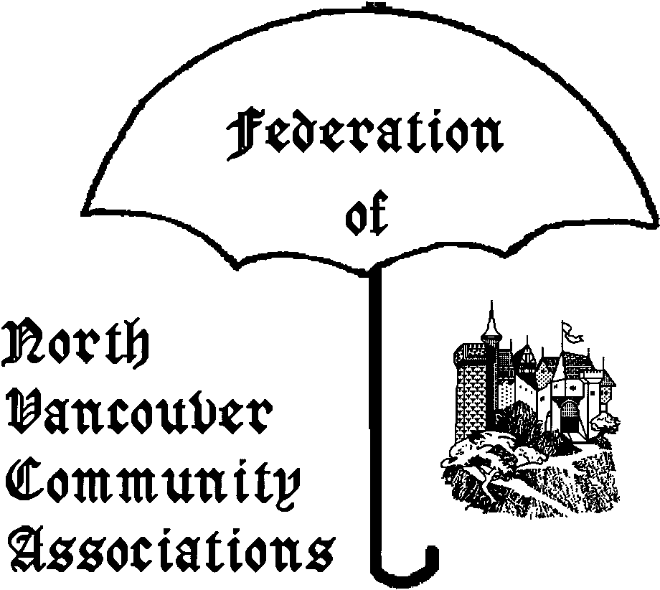
FONVCA AGENDA
THURSDAY November 15th 2007

Place: DNV Hall 355 W. Queens Rd V7N 2K6
Time: 7:00-9:00pm
Chair: John Miller - LCCRA
Tel: 604-985-8594, email: jlmmam@shaw.ca

Regrets:

1. Order/content of Agenda

2. Adoption of Minutes of Oct 18th
http://www.fonvca.org/agendas/nov2007/minutes-oct2007.pdf

3. Old Business
3.1

3.2 Shirtsleeve Review of Nov 14th meeting

3.3 Climate Change Presentation
Review of FONVCA Nov 6th session at Parkgate 7-8:30pm
http://www.fonvca.org/agendas/oct2007/dnvclimatechange.pdf
http://www.fonvca.org/agendas/nov2007/forum-climate-change.pdf

4. Correspondence Issues
4.1 Business arising from 13 regular emails:

4.2 Non-Posted letters – 0 this period

5. New Business
Council and other District issues.

5.1 DNV Appoints New CAO
http://www.dnv.org/article.asp?a=3902&c=484
- Invite to Jan/2008 FONVCA meeting – themes/topics for discussion – views on his priorities – DNV strengths and weaknesses etc…

5.2 Atmospheric CO₂ and Population Growth
http://faculty.washington.edu/blewis/papers/co2/
Removing any doubt about global warming – Corrie Kost

  - Banning of Wood Burning Fireplaces
http://www.fonvca.org/agendas/nov2007/wood-burning.pdf

  - Community Facilities Plans in Chilliwack
http://www.fonvca.org/agendas/nov2007/chilliwack-projects.pdf
All without borrowing…: Corrie Kost

5.5 Conservation of our Forests
-How many trails?
-Hiking vs. Multi-Use vs. Biking

  - Governance:Global Actions and Visioning
Corrie to review summary of WV presentation by
Dr. Martha Piper & Dr. Michael Byers found at
http://www.fonvca.org/agendas/nov2007/governance.pdf

5.7 Workshop on Development Cost Charges
http://www.dnv.org/upload/documents/Council_Workshops/cwm071022.htm
Standards for parkland is proposed to be reduced by 75%
How would this mesh with “sustainability”?

5.7b Earthquakes Threat on the West Coast
Summary of presentation given by GVRD at LSCR (Learning Lodge) 1-3pm 27-Oct-2007.
http://www.fonvca.org/Issues/GVRD/Earthquake-Risk-27oct2007/

  - Trends in Snowpack & Water Supply
Summary of presentation given by GVRD at LSCR (Learning Lodge) 1-3pm 4-Nov-2007.
http://www.fonvca.org/Issues/GVRD/Snowpack-Presentation-3Nov2007/
see also reply to watershed usage/reserves at
http://www.fonvca.org/agendas/nov2007/watershed-reserves.pdf

  - Public Works and Construction Standards
DNV staff reply to questions to a letter sent by Corrie:
- Does new Lynn Valley Library meet 2005 codes?
- Will new filtration plant handle very high turbidity?
http://www.fonvca.org/letters/2007/15oct-to/Gavin_Joyce_4oct2007.pdf

6. Any Other Business
6.1 Legal Issues
Review of process leading to CSB (C5) Rezoning since 1995 PH ( http://www.fonvca.org/agendas/nov2007/csb-1995-nsn-ad.jpg ) . Summary to be distributed at mtg. Next phase: Public Hearing on Nov 20/2007
http://www.dnv.org/upload/documents/Council_PH/ph2071120.htm
http://www.dnv.org/article.asp?a=3910&c=552

6.2 Any Other Issues (2 min each)
- Metro Vancouver’s Latest Growth Management Document http://www.gvrd.bc.ca/growth/pdfs/RGSIssues_Options2007.pdf
- DNV OCP material at www.fonvca.org/OCP/
7. Chair & Date of next meeting.
Thursday January 17th 2008 – Note that tentatively there will be no meeting on December 20th
Attachments
-List of Email to FONVCA - ONLY NEW ENTRIES
OUTSTANDING COUNCIL ITEMS
-Cat Regulation Bylaw –District-wide OCP -Review of Zoning Bylaw
-Securing of vehicle load bylaw -District-wide OCP
-Snow removal for single family homes bylaw.

Correspondence/Subject Ordered by Date
15 October 2007 → 11 November 2007

LINK | SUBJECT
http://www.fonvca.org/letters/2007/15oct-to/Agnes_Hilsen_22oct2007.pdf | DNV Advisory Committees – Disability Issues
http://www.fonvca.org/letters/2007/15oct-to/Agnes_Hilsen_22oct2007b.pdf | Council Procedure – Meaning of “receipt” of report.
http://www.fonvca.org/letters/2007/15oct-to/Corrie_Kost_21oct2007.pdf | DCC – only allocated ¼ of usual neighbourhood parkland
http://www.fonvca.org/letters/2007/15oct-to/Ernie_Crist_22oct2007.pdf | Affordable Housing – Lynn Valley
http://www.fonvca.org/letters/2007/15oct-to/Ernie_Crist_28oct2007.pdf | Charrette -Lynn Valley Town Centre
http://www.fonvca.org/letters/2007/15oct-to/Ernie_Crist_28oct2007b.pdf | District Staff – new CAO David Stuart
http://www.fonvca.org/letters/2007/15oct-to/Ernie_Crist_2nov2007.pdf | Construction Debris on Roadway
http://www.fonvca.org/letters/2007/15oct-to/Gavin_Joyce_4oct2007.pdf | New Lynn Valley Library – Earthquake Standards met?  Water Filtration Plant – Handling of high turbidity?
http://www.fonvca.org/letters/2007/15oct-to/OAG_30oct2007.pdf | Misc: Reports of Auditor General of Canada
http://www.fonvca.org/letters/2007/15oct-to/Wendy_Qureshi_15oct2007.pdf | Lynn Valley Town Centre
http://www.fonvca.org/letters/2007/15oct-to/Wendy_Qureshi_21oct2007.pdf | DNV Advisory Committees – Disability Issues
http://www.fonvca.org/letters/2007/15oct-to/Wendy_Qureshi_22oct2007.pdf | DNV Advisory Committees - Public Notification in NSN
http://www.fonvca.org/letters/2007/15oct-to/Wendy_Qureshi_29oct2007.pdf | Construction Debris on Roadway

For details/history see
http://www.fonvca.org/letters/index-letters-total-nov2007.html

