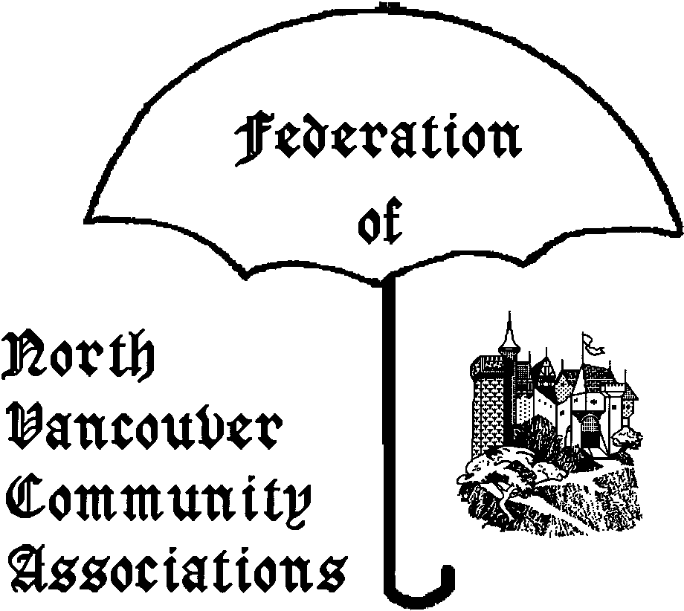
FONVCA AGENDA
THURSDAY September 20th 2007

Place: DNV Hall 355 W. Queens Rd V7N 2K6
Time: 7:00-9:00pm
Chair: Diana Bellhouse – Delbrook C.A..
Telephone: 604-987-1656
Email: none
Regrets:

1. Order/content of Agenda

2. Adoption of Minutes of July 19th
http://www.fonvca.org/agendas/sep2007/minutes-jul2007.pdf

3. Old Business
3.1 Dennis Back reply to “Annual Report”
http://www.fonvca.org/agendas/sep2007/Dennis_Back.pdf

4. Correspondence Issues
4.1 Business arising from 15 regular emails:

4.2 Non-Posted letters – 0 this period
- email to be circulated at meeting

5. New Business
Council and other District issues.

5.1 Alternative to private docks on waterfront.
- Maureen Bragg – Aug 25th email to be distributed.

5.15 Alpine Recreation Update
Comments by Lyle Craver re: Open House & Parking

5.2 Renewal charge for FONVCA web site
http://www.fonvca.org/agendas/sep2007/Renewal-Notice.pdf
1YR:$10/month 5YR:$7/month

5.3 Shirtsleeve Topics – fall meeting
- topic discussion

5.4 BC Rail Lands used as Sewage Plant?
http://www.northshoreoutlook.com/portals-code/list.cgi?paper=43&cat=23&id=1058762&more=0

5.5 “Metro Vancouver” → Amalgamation?
Not likely according to: http://www.northshoreoutlook.com/portals-code/list.cgi?paper=43&cat=23&id=1058765&more=0
2006 Census (see handout) indicates low growth for CNV and DNV

5.6 “CAN” (Cooperative Auto Network)
Details are important!
- http://en.wikipedia.org/wiki/Carsharing
- http://www.cooperativeauto.net/
- http://www.businessedge.ca/article.cfm/newsID/9079.cfm
- http://www.happyfrog.ca/ask-the-frog/questions/zipcar-offering-same-service-cooperative-auto-network

5.65 “Eco-density a thin concept” & Walking more damaging than driving?
- articles to be distributed at Sep 20th meeting.

5.7 FTTx (eg FTTH –Fibre to the Home)
Fibre to the home (as opposed to Neigbourhood/Node, Curb, or Building) is outgrowing all other formats.
http://en.wikipedia.org/wiki/Fiber_to_the_x
http://en.wikipedia.org/wiki/Fiber_to_the_premises
http://harmonica.typepad.com/fiberevolution/FttX-in-Europe-August-2007-A.doc
Downstream signals are broadcast to each premises sharing a fiber. Encryption prevents eavesdropping. – Overview by Corrie

5.8 Natural Hazards Task Force
DNV looking for members - ~2hrs/week Oct/07 to early 2008 to detail tolerable risk criteria for natural hazards.
http://www.dnv.org/upload/documents/Council_Reports/00687.pdf
http://www.fonvca.org/agendas/sep2007/Natural-Hazards-Task-Force.pdf

5.9 Electoral Boundary Commission Mtg
- Report by Cathy Adams
- http://www.bc-ebc.ca/
NorthShore details: http://www.bc-ebc.ca/download/files/pdf/report/09_WebReport_SMPBoundaries_M.pdf

6. Any Other Business
6.1 Legal Issues
Crown Corporations and Municipal Taxes
http://www.tbs-sct.gc.ca/gov-gouv/agent-mandataire/agent-mandataire_e.asp
Recent article that crown corporations must pay their fair taxes to municipalities: http://www.canada.com/vancouversun/news/business/story.html?id=8b9ae57a-b75e-41a0-8e51-5c4a66651eb5
Federal Court judge Justice Luc Martineau ruled that “federal officials cannot arbitrarily decide how much they will pay the city [of Montreal], and overturned decisions by bureaucrats to pay the city considerably less than the city would have received from a private property owner”.
Now about those Vancouver port lands…

6.2 Any Other Issues (2 min each)

7. Chair & Date of next meeting.
Thursday October 18th 2007
Attachments
-List of Email to FONVCA - ONLY NEW ENTRIES
OUTSTANDING COUNCIL ITEMS
-Cat Regulation Bylaw –District-wide OCP -Review of Zoning Bylaw
-Securing of vehicle load bylaw -District-wide OCP
-Snow removal for single family homes bylaw.

Correspondence/Subject Ordered by Date
16 July 2007 → 16 September 2007

LINK | SUBJECT
http://www.fonvca.org/letters/2007/16jul-to/Brian_Platts_12aug2007.pdf | Solid Waste Bylaw
http://www.fonvca.org/letters/2007/16jul-to/Corrie_Kost_6aug2007.pdf | Environment
http://www.fonvca.org/letters/2007/16jul-to/Corrie_Kost_9sep2007.pdf | Recycling
http://www.fonvca.org/letters/2007/16jul-to/Ernie_Crist_10aug2007.pdf | Sewage
http://www.fonvca.org/letters/2007/16jul-to/Ernie_Crist_30aug2007.pdf | Recreation Facilities
http://www.fonvca.org/letters/2007/16jul-to/Ernie_Crist_31jul2007.pdf | Corporate Canada
http://www.fonvca.org/letters/2007/16jul-to/Ernie_Crist_31jul2007b.pdf | Canadian Wages
http://www.fonvca.org/letters/2007/16jul-to/Ernie_Crist_7aug2007.pdf | Sewage
http://www.fonvca.org/letters/2007/16jul-to/Monica_Craver_2aug2007.pdf | Mountain Biking
http://www.fonvca.org/letters/2007/16jul-to/Monica_Craver_7aug2007.pdf | Damage to public forests
http://www.fonvca.org/letters/2007/16jul-to/Monica_Craver_7aug2007b.pdf | Mountain Biking
http://www.fonvca.org/letters/2007/16jul-to/Monica_Craver_9aug2007.pdf | Mountain Biking
http://www.fonvca.org/letters/2007/16jul-to/Monica_Craver_12sep2007.pdf | Mountain Biking
http://www.fonvca.org/letters/2007/16jul-to/Susie_Wickstead_11sep2007.pdf | Bowser Trail
http://www.fonvca.org/letters/2007/16jul-to/Wendy_Qureshi_16sep2007.pdf | Lynn Valley Town Centre

For details/history see
http://www.fonvca.org/letters/index-letters-total-sep2007.html

