**Restrict parking to ease gridlock**

26 Aug 2015 The Vancouver Sun

MICHAEL MCCARTHY: Michael McCarthy is a regular contributor to Postmedia publications.

**Adding stalls to new condo towers will just increase Vancouver’s traffic nightmare**

So, how is your commute going these days? School is coming, so it’s sure to get worse soon. Let me share with you details of my commute. After breakfast, I walk down the hall, make a right at the stairs, and it’s a dozen steps up to my second floor office. There are occasional days when I am delayed to pick up this newspaper from my front porch, which extends my commute to as much as a minute.

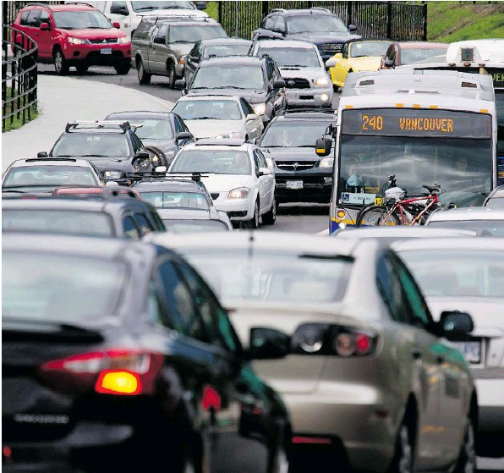*DARRYL DYCK/THE CANADIAN PRESS FILES* Motorists merge from four lanes into one as they enter the Lions Gate Bridge to drive into Vancouver on July 15, 2011. With the population of Metro Vancouver to increase to 3.4 million from the current 2.3 million by 2041, reducing the number of cars on the region’s roads is a major concern.

To paraphrase humorist Mark Twain: “They keep making more people, but they aren’t making any more land.” I understood the meaning after I had the misfortune to drive over the Ironworkers Memorial Bridge from North Vancouver recently. It took me almost two hours to get downtown, where traffic on both main and side streets was bumper-to-bumper. I’m told it frequently is.

In the interests of journalistic integrity, every day afterward I have cycled (my main mode of transportation) to observe “rush hour” on the Upper Levels, which now starts as early as 2 p.m. Traffic is frequently backed up to Taylor Way in West Vancouver. Commute time from there to Burnaby or Vancouver can be as long as two hours. Evidently, it’s just as bad in the morning.

The astounding increase in traffic is evidently due to the huge number of construction workers employed in tearing down perfectly good family houses to build multimilliondollar trophy mansions. Apparently, very few of these workers can afford to live on the formerly affordable North Shore. Highrise towers are also popping up like mushrooms, with complexes planned near the entrance to the Lions Gate Bridge, the Ironworkers Memorial Bridge and Park Royal. All told, thousands of new condos will be built.

Every tower built in the Lower Mainland, even those located right next to the bridges or subway stations where public transit is easily available, will have one or more parking stalls for every new resident. If and when the current building boom ever ends, those thousands of cars driven by construction workers will then be replaced by thousands of new commuters, so the current five hours per day of gridlock could easily continue.

The North Shore is a tightly confined space bounded by the mountains and ocean, accessed by just two bridges. God help anyone needing emergency services. Yet it is merely a microcosm of the entire Lower Mainland, also hemmed in by similar forces. Despite the stress on our roads, calls for more housing continue unabated (especially from the development community) as if growth alone can somehow provide simple solutions to complex issues.

Civic planners predict that by 2041 the number of people in the region will climb from 2.3 million to 3.4 million. Who will be able to buy and live here is one question, but how anyone will be able to get from Point A to Point B is quite another, because we won’t be building any new roads. Gridlock is inevitable.

There is a solution to our traffic nightmare, one that works everywhere it has been applied. Stop allowing parking stalls to be built in new high-density tower developments. At present, 80 per cent of people living in the West End don’t own a car. They walk to work downtown, to the grocery store or bus stop, ride a bike or call a cab. Most live in towers. The West End, despite its density of 45,000 people, remains a highly livable neighbourhood. You don’t need a car when you live close to most necessities.

The rest of the Lower Mainland should copy this successful blueprint. Condo towers should only be allowed close to transit hubs, and only a handful of spaces for short-term parking should be allowed. Residents of major cities like New York and London don’t expect a parking spot to be built for them. Few people there own a private car. Why should we in Vancouver, especially if the population is expected to double? If you need a car, join Modo or another co-op service.

Gridlock is defined in the dictionary as a “traffic jam in which a grid of intersecting streets is so completely congested that no vehicular movement is possible.” In other words, it’s 100 per cent of capacity. If you reduce that number to 95 per cent, traffic moves nicely. Certainly we can take five per cent of the cars off Lower Mainland streets with some constructive planning and not just more mindless construction with unlimited parking.

In the construction of any new tower, the first consideration is to dig a very deep hole and install a few floors with hundreds of parking stalls. Let’s stop that. As an added benefit, condos without any parking cost less to build and to buy, one sure way to lower the cost of housing.

**5 Comment(s)**

[Rancher](http://epaper.vancouversun.com/epaper/showsocialuserprofile.aspx?accnum=ZmzOpFLInJGfMUyqXSyc4A%3d%3d)  
26 August 2015  
05:35

Restrict construction and repair lane and road closures to the evening used to be the norm until the Moonbeamites began to deliberately obstructing traffic by allowing construction lane closures during the day. Combine that with the complete abandonment of j-walking enforcement and grid-lock is a certainty.  And that's their plan.

[Ricketty Rabbit](http://epaper.vancouversun.com/epaper/showsocialuserprofile.aspx?accnum=nPCBDXuHyOKABmSUKG2FuA%3d%3d)  
26 August 2015  
06:34

If authorities were to follow the author's suggestion they'd have to change zoning so towers could not be built except in areas in which walking to efficient transit and local services was convenient.

I lived at Howe and Drake downtown for 6 months in 2009. I found walking convenient except for grocery shopping, which required a car unless one shops every 2 or 3 days. But overall, it was not nearly as convenient as I had expected.

[VPL Library user](http://epaper.vancouversun.com/epaper/showsocialuserprofile.aspx?accnum=6J5PmUcD%2ftw%2bAKVkn6rQUg%3d%3d)  
26 August 2015  
06:58

I've lived in one of the apartment building on the south side of False Creek since 1990. Up until five years ago, I had a car simply because I had to for my work as a mobile service person.  
In 2010 I retired from my job. I sold the family car and started buying monthly bus passes for my wife and myself and - importantly - got a membership in Zipcar, which offers use of a vehicle when you need it for around 10 bucka an hour including the cost of gas, insurance, parking and up to 200 km of driving per trip. In doing this I've reduced our monthly transportation budget from around $500 to about $150. And most importantly I find myself getting to where I want to go as fast, if not faster, than when I drove my own car. I still have my parking stall in the basement of our building but only use it for when we have visitors or I am doing my weekly shopping with a Zipcar.  
Of course it helps that Granville Island is only a 20 minute walk away and likewise it takes about 10 minutes to walk across the Cambie Bridge and be at the foot of Smithe street.  
Our situation in False Creek south is the result of the foresight of planners in the 1970s who wanted to create a model for sustainable living in a big city like Vancouver. Since then it's been a pretty isolated model since realtors and developers have long since taken control of Vancouver city hall, creating the kind of unaffordable condomania we have increasingly been seeing all over the city..  
Basically it has all become being about where the biggest profit margins can be obtained by developers, not what kind of city we want to live in. And this development obviously has the rocksolid approval of our current city council and their gregarious boss...

[Brian Buchanan](http://epaper.vancouversun.com/epaper/showsocialuserprofile.aspx?accnum=UDFg8o%2fztqykoVlMi3Hd3Q%3d%3d)  
26 August 2015  
08:08

An underemployed erstwhile scribbler advocates for more hostility for cars and their owners. He is happy to pedal, so why not everyone? How self serving and infantile is that? He lives like a dependent teenager, and advocates the lifestyle. Does Mommy clean up after him? Likely. Mommy is us.

Most grown-ups with jobs and lives need cars and parking. A bit less naive Ludditism on the setting Sun's fake editorial pages would be helpful, too.

Was it useful?

[street wisdom1](http://epaper.vancouversun.com/epaper/showsocialuserprofile.aspx?accnum=5G4b2Txdv40%2fj0rb8OhIkQ%3d%3d)  
26 August 2015  
08:35

Individual transport is the outcome of people's aspirations to control their lives. Perhaps cost will diminish demand but in reality enjoying the privacy of a commute by car is a choice most people want to make